**UST Students vs. Assignments (Project Code H02)**

**Installation and Instructions**

**Introduction**

Thank you for playing UST Students vs. Assignments! This is a tower defence game developed by students as a school project within a month.

This documentation mainly gives the guide on:

* Installing the game
* How to play
* Project structure
* Developers of the game

(Note: The images shown in the document is not necessary to be the preview of the current version of the game.)

**Installation Guide**

1. Open the project (.pro file) using Qt.

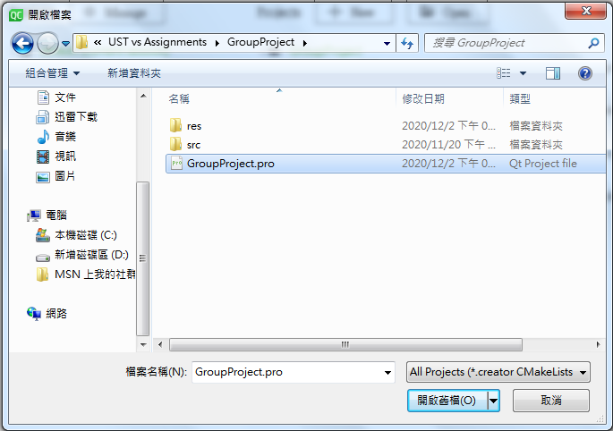

1. 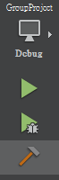Build the project by the ‘Build’ function. We can then either play it by ‘Execute’, or run the .exe file in the ‘debug’ file of the newly created build file.

**Game Instructions**

The game screen is shown as follows:

(It may be different in newer versions. However, the general placement of the objects is similar.)

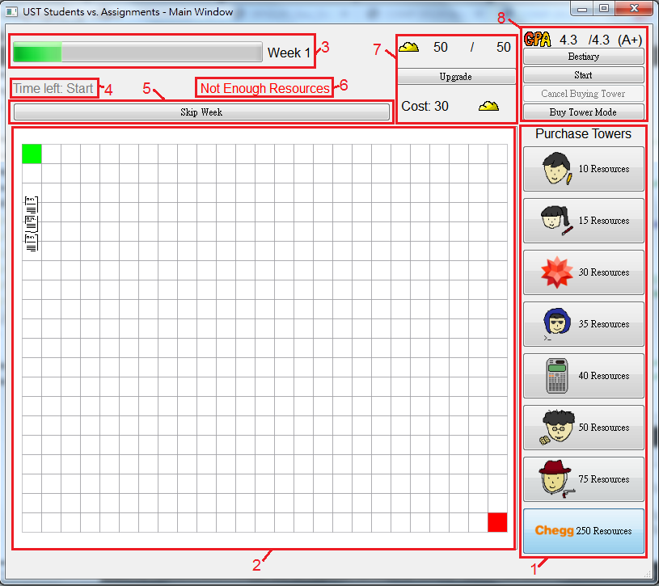

1. Tower purchase list. You can buy towers here, given that you have enough resources.
2. Game grid. The stage where the students versus assignments happen! Green tile is the spawn point of the assignments and the red tile is the finish line of the assignments (deadline). We can build towers there.
3. Your week (wave) progress will be shown here. Varies depending on how many weeks you implemented at the beginning.
4. Time left before the next week.
5. You can skip week there.
6. Warning notification to users (Not enough resources/Invalid placement/etc.)
7. The information about the number of resources you have. This includes resource, resource capacity and resource capacity upgrade.
8. Other manipulations, including GPA (lives), bestiary, start game by loading map and week data, cancel buying tower and toggle buying/selling mode.

At the beginning, we cannot do anything. This includes:

* Buy or place towers
* Upgrade resource capacity
* Toggle buying/selling mode
* Skip weeks

To start the game, we have to press the start button at the right top corner.



Then, we have to open a file that contains the data of each wave.

**Customizing a game**

UST Students vs. Assignments allow players to implement their very own game map and wave data.

The instruction to implement map is as follows:

1. Type out the number of columns and rows of the map at the first line.
2. Draw out the map, with each characters representing different things:

‘#’: Blocked tile (Cannot be passed by enemies and place towers)

‘O’: Entrance (Can only have one for each map)

‘X’: Exit (deadline) (Can only have one for each map)

‘ ’: Empty tile (A space character)

If a map is not implemented, the default map (as shown in the last page) is used.

For example, if we loaded a map file with contents:

|  |
| --- |
| 10 6  ##########  #O # ## #  ### #  #X##### #  # #  ########## |

The instruction to creating a wave data file is as follows:

1. Input a series of enemy ID into the file. Each line of enemy ID represents a wave.
2. Different enemy has different ID. The ID are as follows:
   1. C:\Users\win7\Desktop\HKUST\COMP2012H\UST vs Assignments\GroupProject\res\enemies_images\NormalHW Grid.png Normal Assignments – ID 100
   2. C:\Users\win7\Desktop\HKUST\COMP2012H\UST vs Assignments\GroupProject\res\enemies_images\Essay Grid.png Essay – ID 101
   3. C:\Users\win7\Desktop\HKUST\COMP2012H\UST vs Assignments\GroupProject\res\enemies_images\Encrypted Grid.png Encrypted Homework – ID 102
   4. C:\Users\win7\Desktop\HKUST\COMP2012H\UST vs Assignments\GroupProject\res\enemies_images\GpPrj Grid.png Group Projects – ID 103
   5. C:\Users\win7\Desktop\HKUST\COMP2012H\UST vs Assignments\GroupProject\res\enemies_images\MathHW1 Grid.pngC:\Users\win7\Desktop\HKUST\COMP2012H\UST vs Assignments\GroupProject\res\enemies_images\MathHW2 Grid.pngC:\Users\win7\Desktop\HKUST\COMP2012H\UST vs Assignments\GroupProject\res\enemies_images\MathHW3 Grid.png Mathematics Homework – ID 104
   6. C:\Users\win7\Desktop\HKUST\COMP2012H\UST vs Assignments\GroupProject\res\enemies_images\COMPLab Grid.pngC:\Users\win7\Desktop\HKUST\COMP2012H\UST vs Assignments\GroupProject\res\enemies_images\COMPLab2 Grid.pngCOMP Labs – ID 105
   7. C:\Users\win7\Desktop\HKUST\COMP2012H\UST vs Assignments\GroupProject\res\enemies_images\PA Grid.png Programming Assignments – ID 106
   8. C:\Users\win7\Desktop\HKUST\COMP2012H\UST vs Assignments\GroupProject\res\enemies_images\Desmond Grid.png Desmond – ID 107
   9. C:\Users\win7\Desktop\HKUST\COMP2012H\UST vs Assignments\GroupProject\res\enemies_images\PopQuiz1 Grid.pngC:\Users\win7\Desktop\HKUST\COMP2012H\UST vs Assignments\GroupProject\res\enemies_images\PopQuiz2 Grid.png Pop Quizzes – ID 108
   10. C:\Users\win7\Desktop\HKUST\COMP2012H\UST vs Assignments\GroupProject\res\enemies_images\Midterm Grid.png Midterm – ID 109
   11. C:\Users\win7\Desktop\HKUST\COMP2012H\UST vs Assignments\GroupProject\res\enemies_images\MathsExam Grid.png Mathematics Examination – ID 110
   12. C:\Users\win7\Desktop\HKUST\COMP2012H\UST vs Assignments\GroupProject\res\enemies_images\FinalExam Grid.png Final Examinations – ID 111
   13. C:\Users\win7\Desktop\HKUST\COMP2012H\UST vs Assignments\GroupProject\res\enemies_images\ELPA Grid.png ELPA – ID 112
   14. C:\Users\win7\Desktop\HKUST\COMP2012H\UST vs Assignments\GroupProject\res\enemies_images\FYP Grid.png Final Year Project – ID 113

(Each assignments have different properties. Please refer to the bestiary in the game for detailed descriptions.)

Take an example here. Suppose we loaded the wave data file with contents:

|  |
| --- |
| 100 100 100 100  101 101  102 102 104 104  103 103 103 103 103 103 103 103 103 103 |

Then, the program will recognize the game has 4 waves, with:

Wave 1: 4 Normal Assignments

Wave 2: 2 Essays

Wave 3: 2 Encrypted Assignments and 2 Mathematics Homework

Wave 4: 10 Group Projects

**Playing the Game**

After implementing the map and the wave data, we can now play the game.

After game started, there will be time countdown for 10 seconds before the first wave starts.

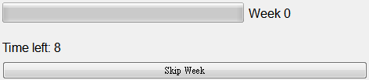

After waiting for 10 seconds, or skip week is clicked, the first week will start. Your objective is to defeat the assignments with towers before they reach deadline.

We can purchase and place a tower when in ‘Buy tower mode’, indicated by the button right above purchasing tower.

All the necessary information of the towers and enemies are in the bestiary window.

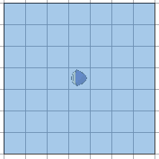If a tower is selected, its range will be shown on the grid. If the tower has an aura, the range will have a different colour. You can cancel select the tower by clicking ‘Cancel buying tower’.

If there are no more assignments to spawn, you can skip to the next week directly.

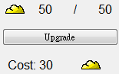More powerful towers require more resources to purchase. However, some require way more than you can have at most at first. You can upgrade the resource capacity by the ‘Upgrade’ button.

Including the initialized one, there are 5 levels of resource capacity

If an assignment reaches the end, your GPA will drop. The drop in GPA depends on how much does the assignment ‘worth’. If your GPA drops to zero, you will be expelled from HKUST (i.e. game over).

Beating the game with different GPA also have different outcome!

**Project Structure**

.

├── build/ # Compiled files (where our .a .o .exe located)

├── docs/ # Documentations (Technical stuff are on Hackmd)

├── src/ # Source files

│ ├── main/ # UI-related implementations

│ ├── enemy/ # enemy interface and implementations

│ ├── tower/ # tower interface and implementations

│ ├── map/ # game map and cell

│ └── utility/ # utilities and game values

├── res/ # Resource file (graphics, demo map/wave data file)

├── group\_project.pro # The .pro file

├── LICENSE

└── README.md

Online documentations (Mostly are draft):

Game flow and UI:

<https://hackmd.io/@G3xU2N67SF2fVm9Hqtva7g/r1GMGfu_D>

Towers:

<https://hackmd.io/@G3xU2N67SF2fVm9Hqtva7g/H1efIRP_v>

Enemies:

<https://hackmd.io/@G3xU2N67SF2fVm9Hqtva7g/BJLXVCDdD>

Utilities:

<https://hackmd.io/@G3xU2N67SF2fVm9Hqtva7g/H1RxZBY_w>

Note that these documentation files are probably outdated since most of them are just drafts for the project.

**Developers**

Group (Project code): H02

Names:

CHAN, Wing Chun

CHAN, Chak Sang

PANG, Lok Chi

Work done for COMP2012H Self-Proposed Project